BACKTRACKING

Table of Contents
LEVEL 1: Easy 2
1. Subsets 2
2. Subsets 2 2
3. Find all permutations of string. 2
4. Permutations 2 2
5. Combination Sum 2
6. Generate Parentheses 2
7. Binary Watch 2
8. Restore IP addresses 2
LEVEL 2: Moderate 3
LEVEL 3: Difficult 4
SOLUTIONS 7
LEVEL 1: 7

LEVEL 1: Easy

Subsets
https://leetcode.com/problems/subsets/

Subsets 2
https://leetcode.com/problems/subsets-ii/

Find all permutations of string
For array version: https://leetcode.com/problems/permutations/

Permutations 2
https://leetcode.com/problems/permutations-ii/

Combination Sum
https://leetcode.com/problems/combination-sum/

Generate Parentheses
https://leetcode.com/problems/generate-parentheses/

Binary Watch
https://leetcode.com/problems/binary-watch/

Restore IP addresses
https://leetcode.com/problems/restore-ip-addresses/

LEVEL 2: Moderate

LEVEL 3: Difficult

Level 2 — Applied Backtracking (grids, strings, constraints)

- Palindrome Partitioning LeetCode 131
- Partition to K Equal Sum Subsets LeetCode 698
- Combination Sum III (LC 216)
- Subsets with sum / target sum style — Partition Equal Subset Sum (LC 416, backtracking + memo angle)
- Matchsticks to Square LeetCode 473
- Word Search LeetCode 79
- Word Search II LeetCode 212
- Rat in a Maze GFG
- N Queens LeetCode 51
- N Queens II LeetCode 52
- Sudoku Solver LeetCode 37
- Letter Tile Possibilities LeetCode 1079
- Split String into Descending Consecutive Values LeetCode 1849
- Split a String Into Maximum Number of Unique Substrings LeetCode 1593
- Beautiful Arrangement LeetCode 526
- Fair Distribution of Cookies LeetCode 2305
- The Number of Beautiful Subsets LeetCode 2597
- Path with Maximum Gold (LC 1219) — grid backtracking with return-value aggregation

Level 3 — Advanced / FAANG bar-raiser tier
- Word Break II (LC 140) — backtracking + memoization
- Remove Invalid Parentheses (LC 301)
- Partition to K Equal Sum Subsets (LC 698)
- Matchsticks to Square (LC 473) — same pattern family as above, good paired drill
- Regular Expression Matching (LC 10) — backtracking + memo, frequently paired with DP framing
- Wildcard Matching (LC 44) — same family
- Splitting a String Into the Max Number of Unique Substrings (LC 1593)
- Remove Invalid Parentheses LeetCode 301
- Expression Add Operators LeetCode 282
- Maximum Score Words Formed by Letters LeetCode 1255
- Optimal Account Balancing LeetCode 465
- Unique Paths III LeetCode 980
- Cherry Pickup LeetCode 741 (Backtracking + DP insight)
- Robot Room Cleaner LeetCode 489
- Maximum Length of a Concatenated String with Unique Characters LeetCode 1239
- Brace Expansion LeetCode 1087
- Brace Expansion II LeetCode 1096
- Strobogrammatic Number II LeetCode 247
- Additive Number LeetCode 306
- Confusing Number II LeetCode 1088

SOLUTIONS

LEVEL 1:

- Subsets
Method 1:
class Solution(object):
def subsets(self, nums):
def rec(i,osf):
if i==len(nums):
ans.append(osf)
return
rec(i+1, osf+[nums[i]]) #creating new array
rec(i+1, osf)

ans = []
rec(0,[])
return ans

Method 2:
class Solution(object):
def subsets(self, nums):
def rec(i,osf):
if i==len(nums):
ans.append(osf[:]) #creates copy and put in ans
return #since osf is modified many times, we need snapshot at that moment

osf.append(nums[i]) #only one osf(add value)
rec(i+1,osf)
osf.pop() #pop value from osf
rec(i+1, osf)

ans,v = [],[]
rec(0,v)
return ans

Method 2 (backtracking) is more optimized.
Why: Method 1 creates a new list (osf+[nums[i]]) at every single recursive call — both the "include" and "exclude" branches — so you're doing O(n) copy work at every node of the recursion tree (which has 2^(n+1)-1 nodes total). That's a lot of wasted allocation, since most of those intermediate lists are never actually the final answer.
Method 2 uses one shared, mutable list (osf) that's modified in-place via append/pop — O(1) work per step — and only pays the O(n) copy cost (osf[:]) at the leaves (2^n of them), which is exactly where you actually need a snapshot for the answer.
Significant improvement? Yes — asymptotically both are still O(n * 2^n) (unavoidable, since that's the size of the output itself), but Method 2 has a much smaller constant factor: it avoids copying at every internal node, only copying 2^n times instead of roughly 2^(n+1) times, and uses append/pop (O(1)) instead of list concatenation (O(n)) for the non-leaf work. This is also less garbage for the GC to clean up, since Method 1 litters the heap with throwaway intermediate lists at every branch.
Rule of thumb: whenever you see osf + [x] or s + "R" in recursion, that's a red flag for unnecessary copying — switch to append/pop (backtracking style) whenever the same structure is reused across recursive calls, and only copy when you actually need to freeze a snapshot (typically at the base case).

- Subsets 2
class Solution(object):
def subsetsWithDup(self, nums):

def rec(i, osf):
if i == len(nums):
ans.append(osf[:])
return
osf.append(nums[i])
rec(i+1, osf)
osf.pop()

j = i # 2. skip all duplicates of nums[i]
while j < len(nums) and nums[j] == nums[i]:
j += 1
rec(j, osf)

nums.sort() # 1. sort so duplicates are adjacent
osf,ans = [],[]
rec(0, osf)
return ans # 3. return the answer

Approach: Same include/exclude backtracking as Subset 1, but with one key addition — after sorting, when you exclude an element, you skip ahead past all its duplicates too. This prevents generating the same subset twice from two different "copies" of the same value.
Why duplicates cause problems without sorting + skipping:
For nums = [1,2,2], if you treat both 2s as independent choices, you'd generate [1,2] twice — once using the first 2, once using the second 2 — since the algorithm can't tell them apart once they're in the output list.

For [1,2,2] -> when exploring we get [1,2] with take. And [1] from skip at index 1. Now to get just [1], you have to skip index 2 also.
Final answer: [[1,2,2], [1,2], [1], [2,2], [2], []] — 6 subsets, correctly matching 2^3 / (no extra dupes), instead of the 8 you'd get (with repeats) if duplicates weren't skipped.
The essence:
- Include branch never needs the skip — including duplicates one at a time is exactly how you build subsets like [2], [2,2] progressively.
- Exclude branch needs the skip because "exclude this value" is a decision about the value, not the specific index — so once you've decided to exclude 2, you must exclude all adjacent 2s in that same branch, or you'll re-explore the identical subset tree multiple times.
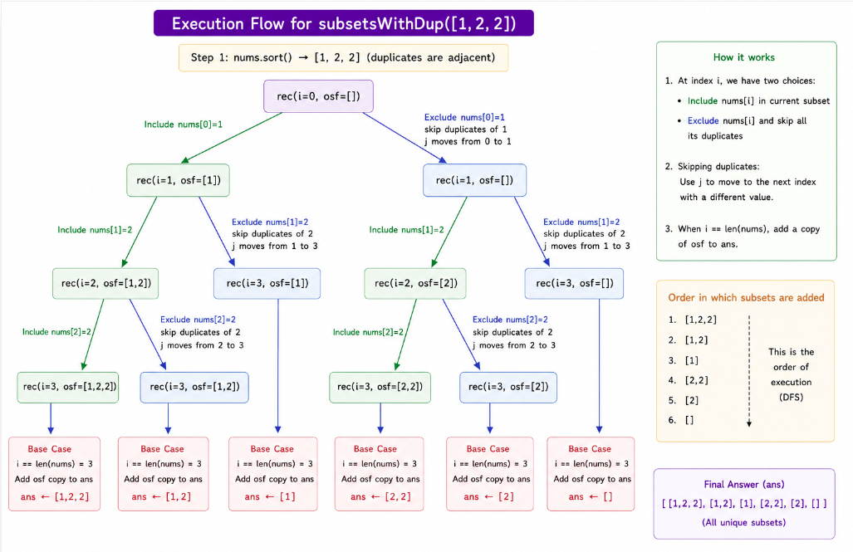

- Permutations of String
# Rule of thumb: if a recursive problem only needs one valid path down the tree, it's plain recursion (like factorial, gcd). If it needs to explore multiple choices at each step and systematically try every branch — often with an explicit "undo" step — that's backtracking. Permutations, subsets, N-Queens, Sudoku solvers all fall into this second category.
def permutations(i,s):
if i == len(s):
print(''.join(s))
else:
for j in range(i,len(s)):
s[i],s[j] = s[j],s[i]
permutations(i+1,s)
s[i],s[j] = s[j],s[i]

permutations(0,list('abc'))

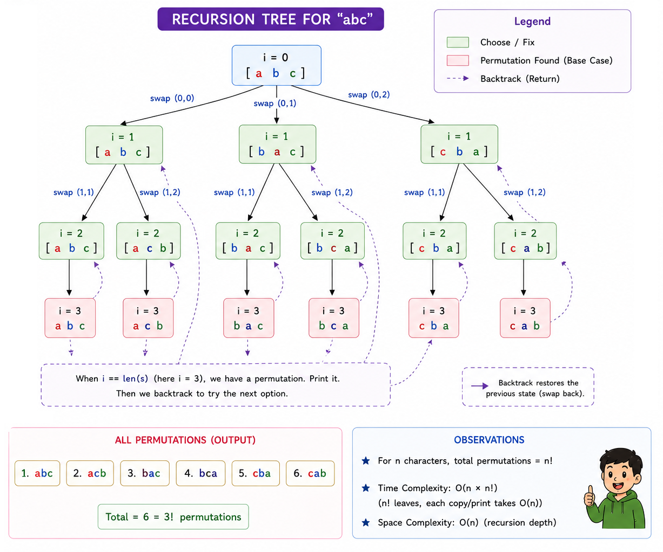

- Permutations 2
The core problem: the swap-based approach physically rearranges nums, so sorting + "skip adjacent duplicates" (like in Subsets 2) won't work directly — after swapping, duplicates are no longer guaranteed to sit next to each other in the array. You need a different dedup strategy: track which values have already been placed at this position in the current loop.
Change needed: at each recursion level, use a set to skip values you've already tried in that position (across sibling branches of the loop):
class Solution(object):
def permuteUnique(self, nums):
def rec(i):
if i==len(nums):
ans.append(nums[:])
return

seen = set()
for j in range(i,len(nums)):
if nums[j] in seen:
continue
seen.add(nums[j])

nums[i],nums[j] = nums[j],nums[i]
rec(i+1)
nums[i],nums[j] = nums[j],nums[i]

ans=[]
rec(0)
return ans

Why this works: the loop for j in range(i, len(nums)) is trying every candidate value for position i. If two different js hold the same value, swapping either one into position i produces the same prefix, leading to identical permutation trees underneath — so seen ensures each distinct value is only tried once per position, regardless of how many duplicate copies exist in the remaining array.
Example — nums = [1,1,2], at rec(0):
- j=0: nums[0]=1 → not in seen → try it → seen={1}
- j=1: nums[1]=1 → already in seen → skip (would've produced the exact same permutations as j=0)
- j=2: nums[2]=2 → not in seen → try it → seen={1,2}
Note — no sorting needed here: unlike Subsets 2, this technique works regardless of the initial order of nums, since seen is rebuilt fresh at every recursion level and only tracks "value already tried in this position," not "adjacent duplicates."

- Combination Sum
Approach: at each candidate, you have two choices — reuse the same element again (since repetition is allowed) or move on to the next candidate — and you keep a running total to track progress toward target.

class Solution(object):
def combinationSum(self, candidates, target):
def rec(i,osf,total):
if total==target:
ans.append(osf[:]) #don't forget to add copy (snapshot at given time)
return
if i==len(candidates) or total>target:
return

osf.append(candidates[i])
rec(i,osf,total+candidates[i]) #again take ith value
osf.pop()
rec(i+1,osf,total) #ignore ith and move to i+1

candidates.sort()
ans,osf = [],[]
rec(0,osf,0)
return ans

Include branch (rec(i, osf, total+candidates[i])): stays at the same index i, not i+1, because combinationSum allows using the same number multiple times — so after picking candidates[i], you can pick it again.
Exclude branch (rec(i+1, osf, total)): moves to i+1, permanently skipping candidates[i] for the rest of this path — this is what eventually terminates the "reuse" loop, since without it you'd try to reuse the same element forever.
Base cases:
- total == target → found a valid combination → save a snapshot (osf[:]) and stop.
- i == len(candidates) (ran out of candidates) or total > target (overshot) → dead end, backtrack.
Why sort first: sorting isn't strictly required for correctness here (no duplicate-skipping logic is used), but it enables the early-exit optimization total > target to prune faster — once running total exceeds target with sorted (ascending) candidates, adding any larger remaining candidate will only make it worse, so this path can be abandoned early instead of exploring further.

- Generate Parentheses
Intuition: at each step, greedily try adding (whenever you haven't used all n yet, and try adding ) only when there's an unmatched ( to close (r < l) — this "check validity before choosing" backtracking naturally generates only well-formed strings, with l==r==n marking a complete valid combination.
class Solution(object):
def generateParenthesis(self, n):
def rec(l,r,osf):
if l>n or r>n: #invalid cases
return
if (l+r) == 2*n: #osf length==2*n
ans.append(''.join(osf))
return

osf.append("(")
rec(l+1,r,osf)
osf.pop()
#r<l : to have balanced paranthesis
if r+1<=l: #() (()) ((()))
osf.append(")")
rec(l,r+1,osf)
osf.pop()

ans=[]
rec(0,0,[])
return ans

Method 2:

class Solution(object):
def generateParenthesis(self, n):
def rec(l, r, osf):
if l == n and r == n:
ans.append(''.join(osf))
return
if l < n: #only try '(' if it's still valid
osf.append("(")
rec(l+1, r, osf)
osf.pop()
if r < l: #only try ')' if it won't exceed unmatched '('
osf.append(")")
rec(l, r+1, osf)
osf.pop()
ans=[]
rec(0,0,[])
return ans

Why method 2 is better: Removes calls with l>n/r>n. Now all recusions generated valid path. This also decrease counts of append and pop action, improving the performance.
- Binary Watch
Approach: backtrack over all 10 LED positions (4 hour bits + 6 minute bits), choosing to light each one or not, and only keep combinations where the total lit count equals turnedOn and the resulting hour/minute are valid.

class Solution:
def readBinaryWatch(self, turnedOn: int) -> List[str]:

def rec(i, count, h, m):
if count == turnedOn:
if h <= 11 and m <= 59:
ans.append(f"{h}:{m:02d}")
return
#add base case later, as when i==10, we may have valid cases
#so may have to write above check code again
if i == 10 or count > turnedOn: #base case
return

if i < 4: # choose light up LED i
rec(i+1, count+1, h+values[i], m)
else:
rec(i+1, count+1, h, m+values[i])

rec(i+1, count, h, m) # skip LED i

ans = []
values = [8, 4, 2, 1, 32, 16, 8, 4, 2, 1] #first 4= hour bits, last 6=minute bits
rec(0, 0, 0, 0)
return ans

Why this is backtracking, not brute enumeration: at every LED position you make a binary choose/skip decision (same "include/exclude" pattern as subsets), and you prune early with count > turnedOn so you never waste time exploring branches that have already lit too many LEDs.

- Restore IP Addresses
Approach: backtrack by trying every possible length (1, 2, or 3 digits) for each of the 4 segments, validating each segment as you go (0-255, no leading zeros) — classic "choose → recurse → undo" over segment boundaries.

class Solution:
def restoreIpAddresses(self, s):
ans = []
n = len(s)

def valid(seg):
if len(seg) > 1 and seg[0] == '0': # no leading zeros (except "0" itself)
return False
return 0 <= int(seg) <= 255

def rec(i, parts):
# pruning: too many parts already, or remaining chars can't fit in what's left
if len(parts) == 4:
if i == n:
ans.append('.'.join(parts))
return

for length in range(1, 4): # try 1, 2, or 3 digit segments
if i + length > n:
break
seg = s[i:i+length]
if valid(seg):
parts.append(seg)
rec(i+length, parts)
parts.pop() # backtrack

rec(0, [])
return ans

Why this is efficient: at each position you only try 3 possible segment lengths (1, 2, or 3 digits) instead of trying every possible split point — since IP segments are capped at 255, no valid segment can ever be longer than 3 characters. This keeps the branching factor tiny (max 3-way choice per step) rather than exploring all 2^(n-1) possible split combinations.

